**RAMANUJAN CLUB FOR INNOVATIONS IN MATHEMATICS (RCIM)**

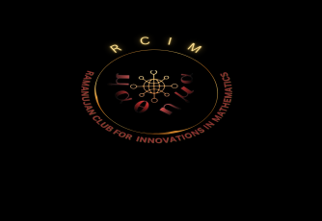

**“In Mathematics the art of proposing a question must be held of higher value than solving it”.**

***-Georg Cantor, German***

Math is a linear learning process. It gives us a way to understand patterns, to quantify relationships and to predict the future. Math helps us understand the world and we use the world to understand Math. Mathematics is the science that deals with the logic of shape, quantity and arrangement. It is useful way to think about nature and our world. Mathematics exists everywhere and it is applied in the most useful phenomenon. It is an integral part of daily life formal and informal. It is used in technology, business, medicine, natural and data sciences, Machine learning and construction. It is not just about numbers, most of it problem solving and reasoning, inductive and deductive. It also discusses also intuition, Proof and certainty

Shri. Srinivasa Ramanujan was one of India’s greatest Mathematical geniuses. He made substantial contributions to the analytical theory of numbers and worked on elliptic functions, continued fractions, and infinite series. Every year, on December 22, India observes its National Mathematics day in honour of Shri. Srinivasa Ramanujan, regarded as one of the greatest Mathematicians to ever grace the planet. He says:

**“An Equation Means Nothing to me Unless It Expresses a thought of God”**

In this regard, to honour Shri Srinivasa Ramanujan and inculcate his Mathematical temper into the young minds, the Department of Science & Humanities started a Mathematics club in the name of “**RAMANUJAN CLUB FOR INNOVATONS IN MATHEMATICS (RCIM)”.** There should be a scope of learning beyond class room confinement to widen the knowledge of students and to provide exposure for real life problems relating to society. It helps the students in having an idea of the practical utility of Mathematics in addition to creating their interest in Mathematics and to encourage their creativity. It helps our students get to grips with a wide range of Mathematical Principles. Its mainly to encourage passionate engagement with mathematics by promoting diverse activities that go beyond regular classroom learning.